COMPENG 4TL4 | DSP

Lab 5: FIR and IIR Filter Design and Analysis

Instructor: Dr. Ratnasingham Tharmarasa

Lab TA: Saad Nafees

Dec 5, 2024

Arjun Bhatia – bhatia32 – 400341269

Ahmad Choudhry — chouda27 — 400312026

As a future member of the engineering profession, the student is responsible for performing the required work in an honest manner, without plagiarism and cheating. Submitting this work with my name and student number is a statement and understanding that this work is my own and adheres to the Academic Integrity Policy of McMaster University and the Code of Conduct of the Professional Engineers of Ontario. Submitted by **Arjun Bhatia, bhatia32, 400341269**

As a future member of the engineering profession, the student is responsible for performing the required work in an honest manner, without plagiarism and cheating. Submitting this work with my name and student number is a statement and understanding that this work is my own and adheres to the Academic Integrity Policy of McMaster University and the Code of Conduct of the Professional Engineers of Ontario. Submitted by **Ahmad Choudhry, chouda27, 400312026**

1. The truncation method of FIR design

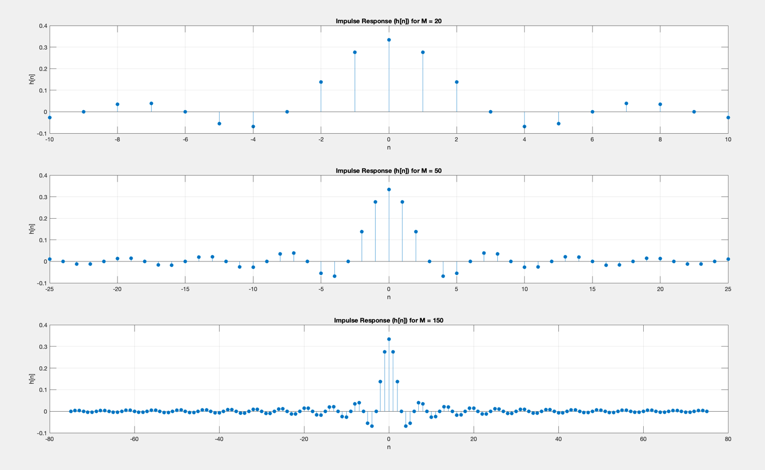

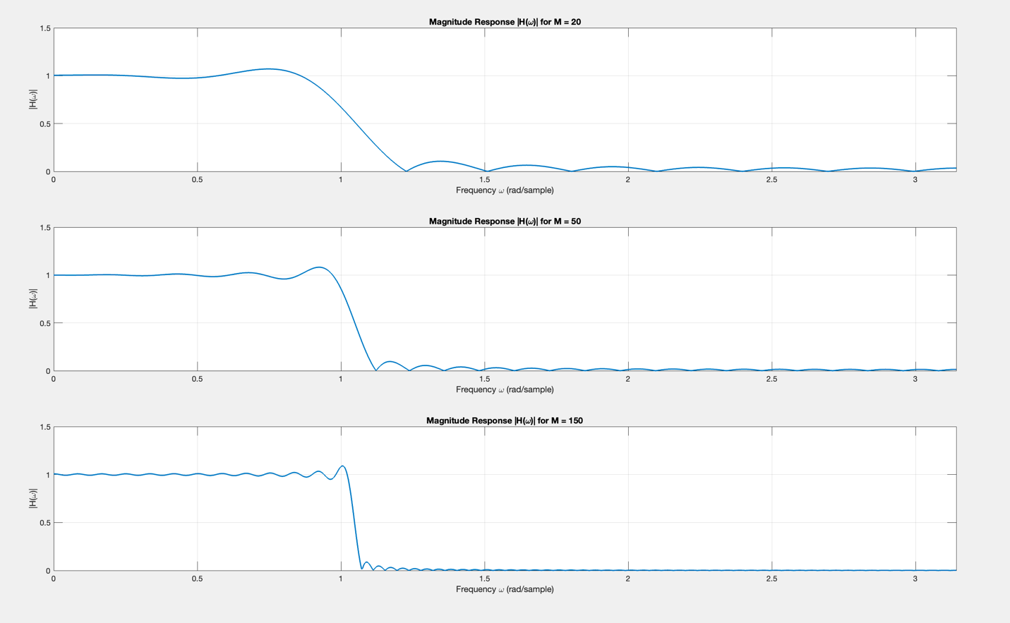

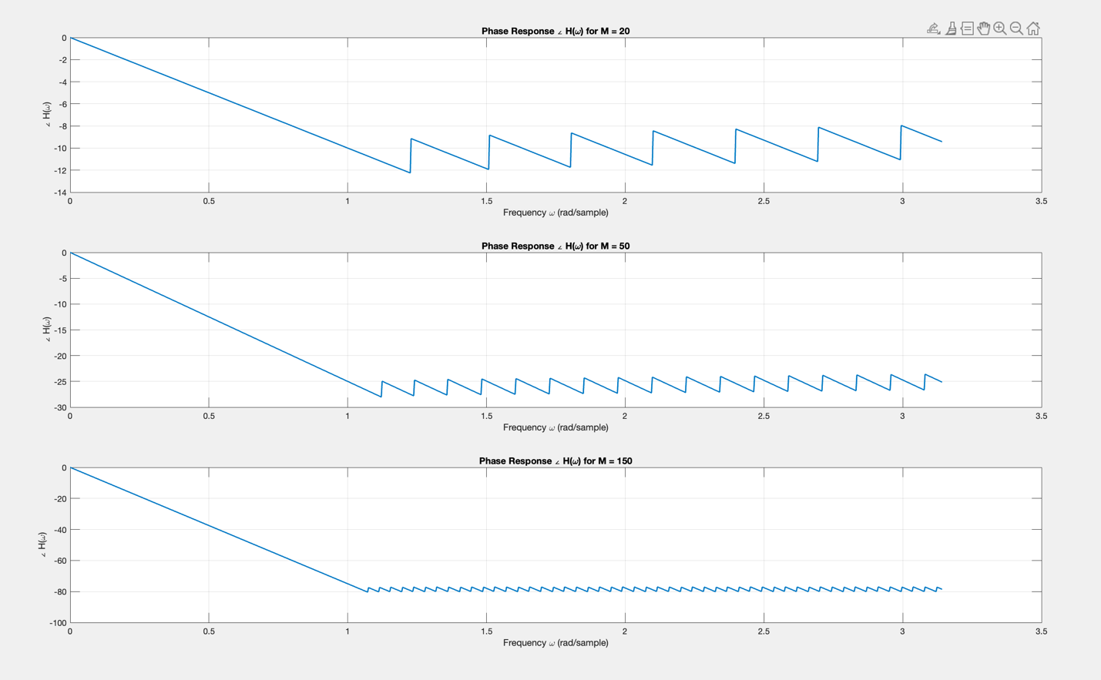

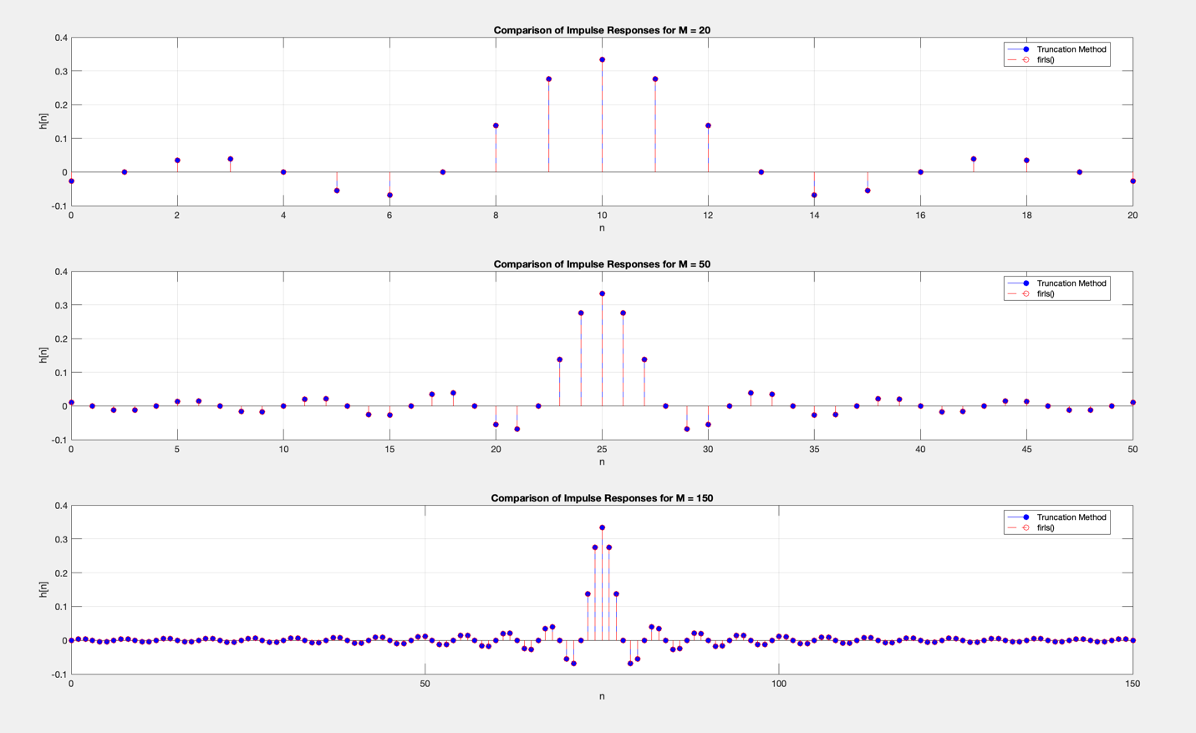

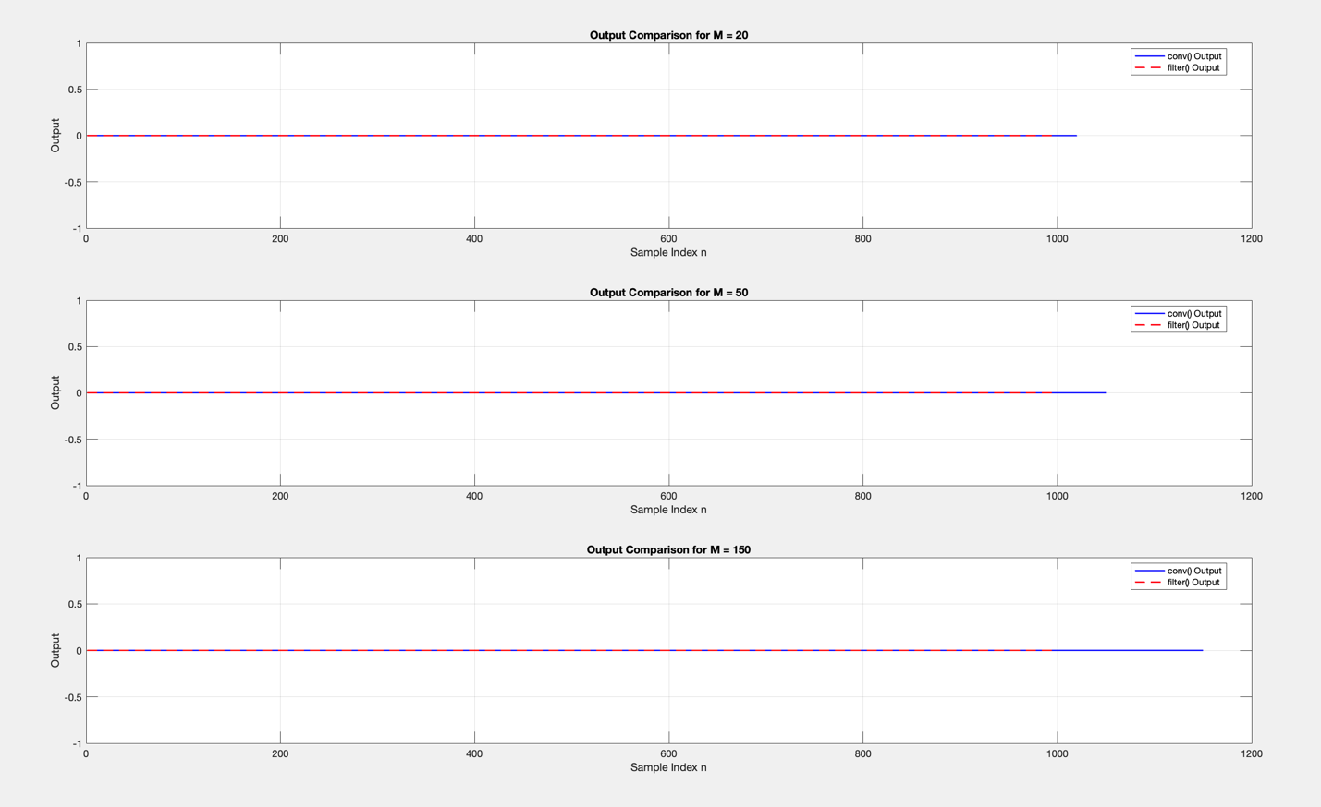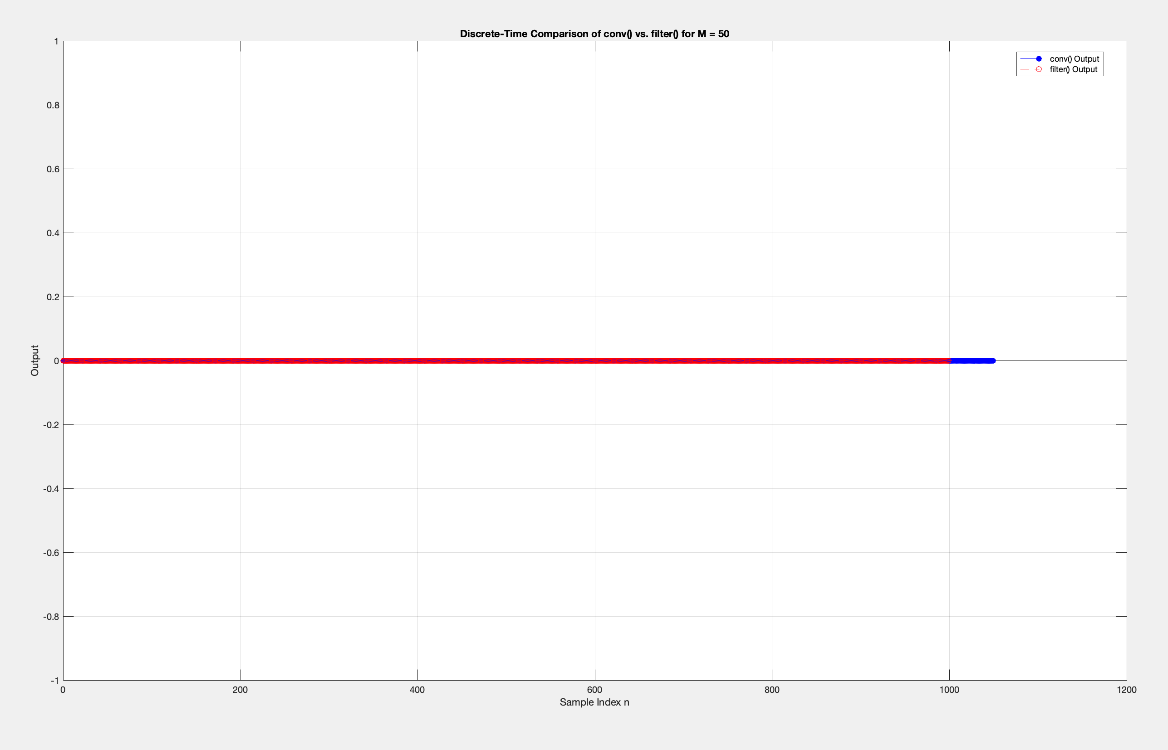

**(a)** Using the truncation method to design linear-phase lowpass FIR filters at \omega_c = \pi/3 for filter lengths M = 20, 50, 150 (i.e., N = M + 1 = 21, 51, 151 ), you start from the ideal lowpass response in the frequency domain and obtain the corresponding infinite-length sinc-type impulse response. By truncating this infinite impulse response to N samples (centered around the main lobe), you create the FIR filter. The figures show the following trends:

• **Impulse Response:** As the filter length increases (from M=20 to M=150 ), the truncated sinc function’s main lobe remains centered, but more sidelobes are included on either side. For M=20 , you only have a small number of sidelobes, whereas for M=150 , the impulse response is longer, capturing more of the ideal sinc’s tail.

• **Magnitude Response:** Longer filters (higher M ) produce a narrower transition band, leading to a sharper cutoff. However, the Gibbs phenomenon—ripple-like oscillations in both the passband and stopband—remains present. Increasing the filter length reduces the width of these oscillations (making the transition steeper) but does not eliminate them entirely.

**(b)** **Gibbs Phenomenon:** The magnitude responses clearly exhibit rippling near the transition band. These oscillations do not vanish as M increases; instead, the ripples become more frequent and the transition region becomes sharper. This is the classic Gibbs phenomenon resulting from abruptly truncating the ideal (non-causal, infinite) impulse response.

**(c)** **Linear Phase Confirmation:** The phase responses plotted for each filter order are linear (essentially a straight line with a constant slope). Even though there are “wraps” due to phase unwrapping conventions, the underlying trend is linear. This linear-phase characteristic is expected since the truncated impulse response is symmetric around its midpoint.

**(d)** **Comparison to FIRLS:** The MATLAB firls() function, which designs linear-phase FIR filters using a least-squares error minimization approach, produces impulse responses nearly identical to those obtained via the truncation method for the same filter lengths. The figures comparing these methods show negligible differences, confirming that for this particular ideal lowpass design, simple truncation and least-squares design yield essentially the same filter coefficients.

**(e)** **Convolution vs.** filter() **Output:** When a 1000-sample white Gaussian noise signal is passed through these FIR filters, performing the filtering using direct convolution with the impulse response (conv()) and using the MATLAB filter() function produce essentially identical outputs. The plots of the outputs show the two curves overlapping almost perfectly. Minor differences, if any, may stem from initial conditions or negligible floating-point arithmetic variations. Both methods implement linear convolution, so the results are the same.

2. Chebyshev Type II lowpass IIR filter

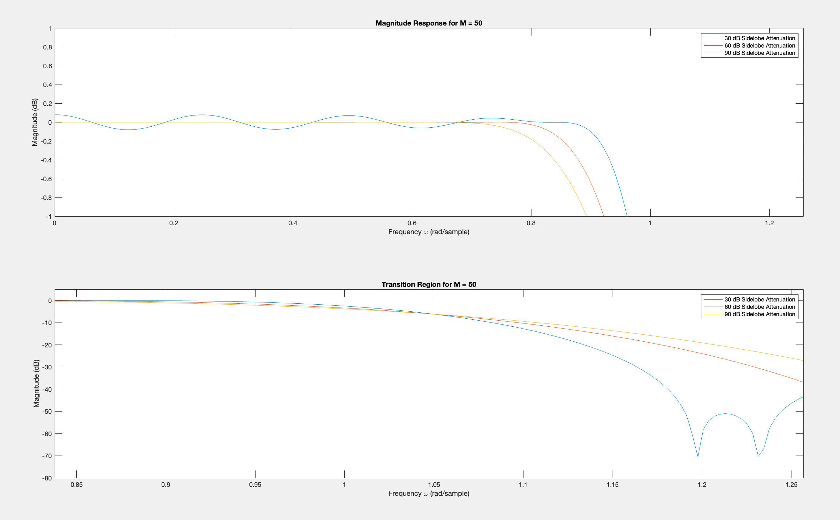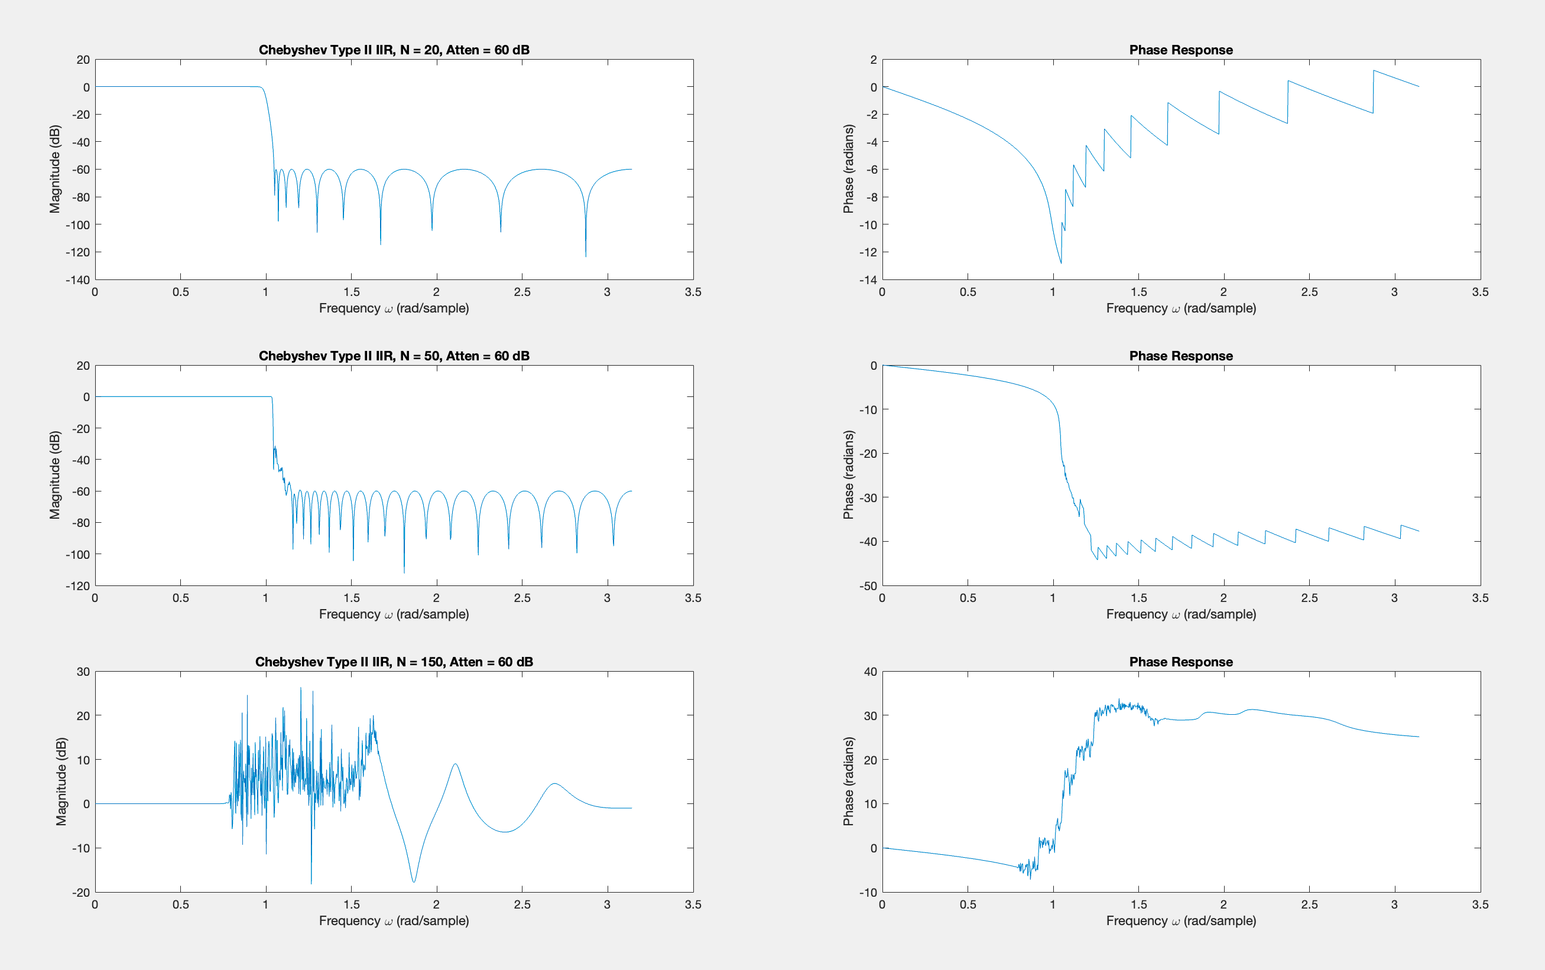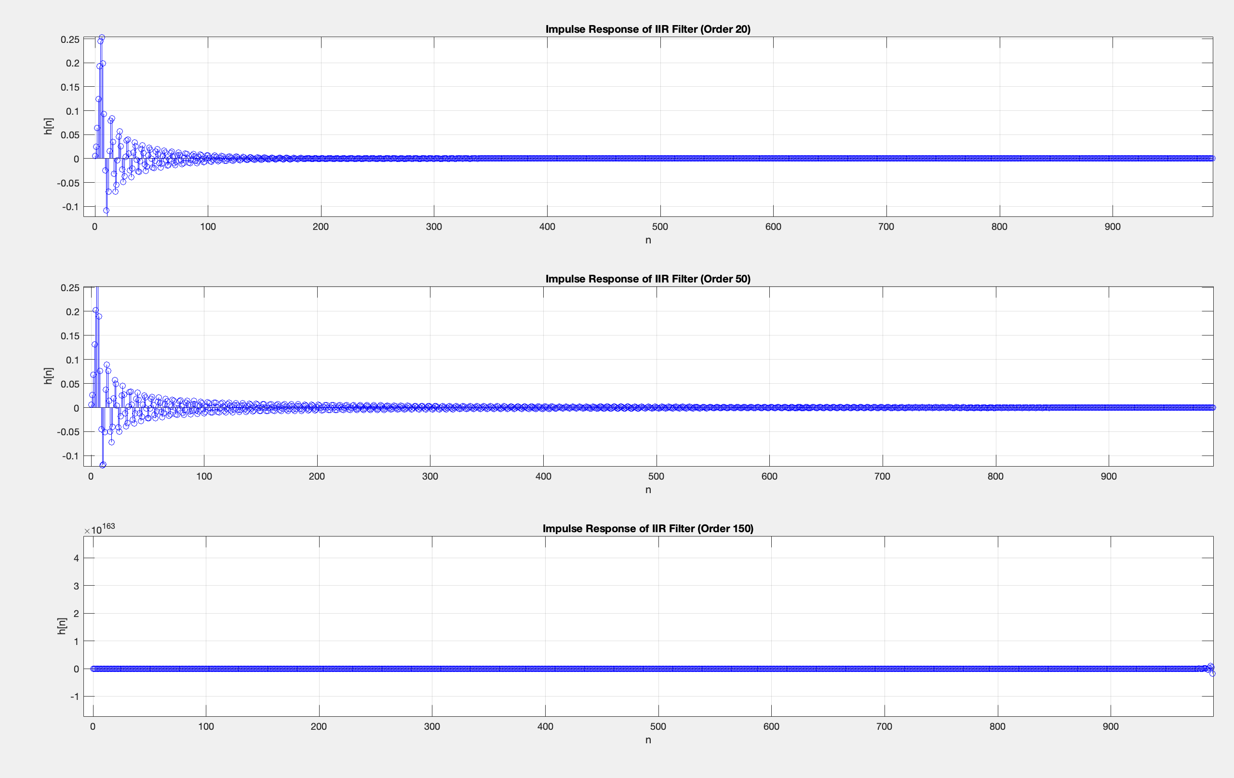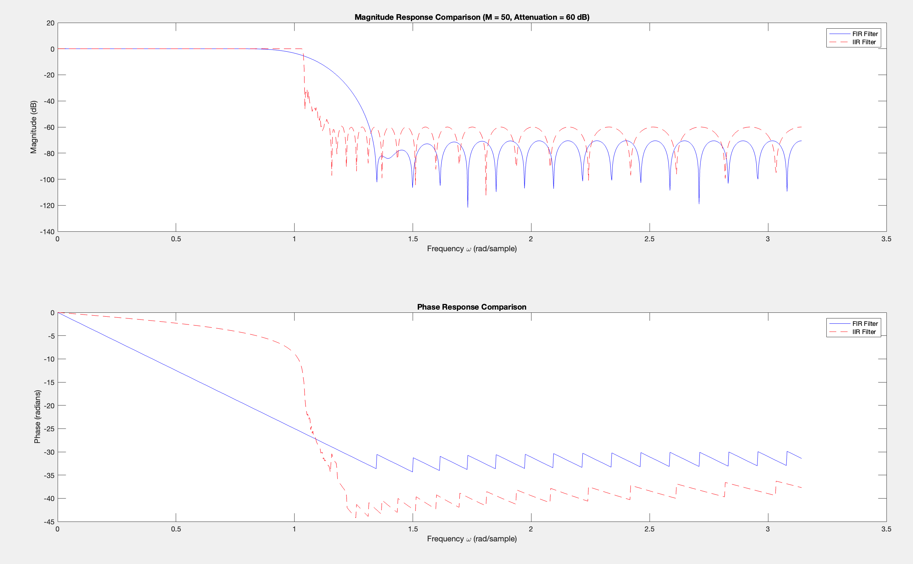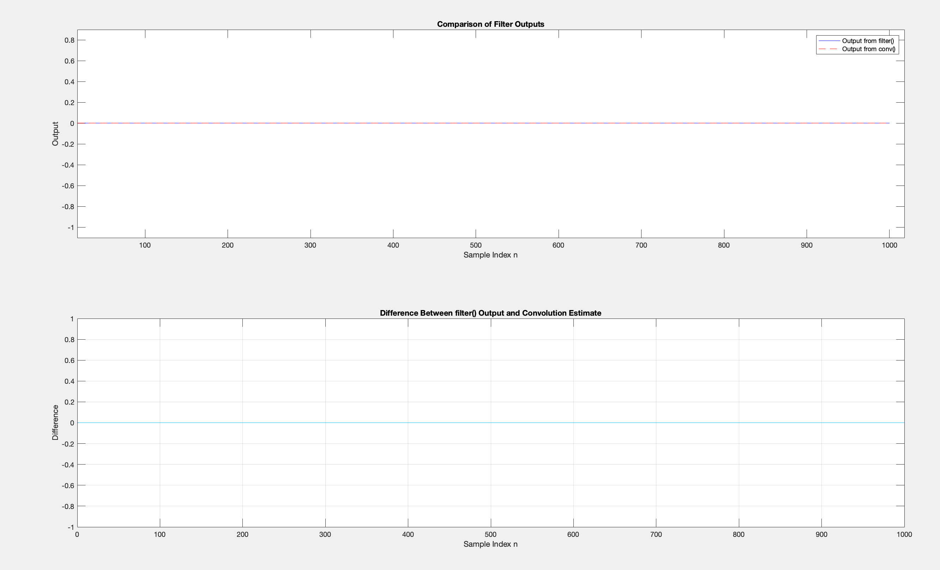**(a)** For the FIR filters designed using Dolph-Chebyshev windows, the figures show that as the filter order M increases (from 20 to 50 to 150), two main effects become evident:

1. **Passband ripple and stopband attenuation:** Increasing the sidelobe attenuation of the Dolph-Chebyshev window reduces passband ripple and enhances stopband attenuation. For a given attenuation setting, higher-order filters (e.g., M=150 ) achieve deeper stopbands and lower passband ripple compared to lower-order filters (e.g., M=20 ). This is visible in the magnitude response plots where the larger-order FIR filter curves exhibit more pronounced attenuation in the stopband and smoother (less rippled) passband regions.

2. **Transition region slope:** As the order increases, the transition from passband to stopband becomes steeper. The higher-order filter achieves a sharper cutoff, as clearly shown by the more abrupt drop in the magnitude response. In other words, you get a narrower transition band with increasing M .

**(b)** For the Chebyshev Type II IIR filters, the frequency responses designed at the same cutoff and similar stopband attenuation as the FIR filters show characteristic stopband ripples analogous to the FIR’s sidelobes. However, unlike the FIR filters:

• The IIR filters do not maintain linear-phase behavior; their phase response is nonlinear and can be seen “wavering” significantly in the plotted phase responses.

• The IIR filters generally achieve similar stopband attenuation with fewer coefficients compared to their FIR counterparts. As the IIR filter order increases (20, 50, 150), the magnitude response gains sharper transitions and deeper attenuation, similar to the FIR scenario, but with notable differences in the phase response and potential numerical complexity at very high orders.

**(c)** The impulse responses of the IIR filters, as shown in the time-domain plots, do not neatly terminate like the FIR filters. While FIR filters have a finite-length impulse response, the IIR filters exhibit responses that extend indefinitely, decaying gradually or stabilizing slowly. For modest orders (N=20, N=50), the impulse responses settle into a small but nonzero tail. At very high order (N=150), numerical issues and accumulation of round-off errors can cause the impulse response to appear unstable or have extremely large values before settling. Thus, the IIR filters’ impulse responses appear to be infinite in duration, as expected.

**(d)** Comparing the frequency responses of the IIR filters to the FIR filters:

• **Magnitude Response:** Both can achieve similar attenuation levels in the stopband. The FIR filters with Dolph-Chebyshev windows have controlled, predictable sidelobe behavior and linear phase. The Chebyshev II IIR filters have equiripple stopbands but are not constrained to linear phase.

• **Phase Response:** FIR filters designed using symmetric windows are linear-phase, resulting in minimal distortion of signal waveforms. The IIR filters, in contrast, have nonlinear phase responses, as evident in the figures by their nonuniform, rapidly changing phase characteristics. This difference arises from the fundamental filter structures: FIR filters can be made linear-phase by symmetric coefficient arrangements, whereas IIR filters are generally not linear-phase.

In summary, the FIR filters offer linear phase and stable performance at all orders, while the IIR filters achieve similar attenuation with potentially fewer coefficients but suffer from nonlinear phase and infinite impulse responses.

**(e)** When filtering a 1000-sample white Gaussian noise input using the filter() function (direct IIR filtering) versus convolving with the IIR filter’s long impulse response estimate, the accuracy of the convolution-based output depends on how well the infinite-duration tail of the IIR impulse response is approximated. The figures comparing these outputs show that, for lower-order IIR filters with reasonably fast decaying tails, the convolution estimate closely matches the direct filter output. However, as filter order and complexity increase, the impulse response becomes very long and possibly ill-conditioned. If the tail is truncated too soon, the convolution-based output deviates from the actual filtered output, as indicated by the difference plots. In practice, for very high-order IIR filters, a long truncation length is required to achieve a good approximation, and even then, numerical issues may degrade the accuracy.

3. Detecting Targets in Background Clutter Utilizing a Moving Target Indicator  
with the TMS 320 DSP Processor

The oscilloscope results demonstrate the effectiveness of different filtering approaches in target detection. Without MTI filtering, the static barrier signals dominate, obscuring moving targets due to the lack of distinction between static and dynamic components. The two-pulse canceller shows improvement by partially canceling static signals and revealing moving targets, though some noise remains. The three-pulse canceller further enhances filtering by attenuating low-frequency components more effectively, resulting in better separation of moving targets from background clutter. When combined with the Hanning window, the three-pulse canceller achieves the best performance, reducing spectral leakage and improving the signal-to-noise ratio (SNR) by smoothing the frequency response. Overall, the progression from no MTI to the three-pulse canceller with a Hanning window highlights the effectiveness of these techniques for radar signal processing.

• **Without MTI**: Static barrier signals dominate, making target detection difficult.

• **Two-Pulse Canceller**: Partial cancellation of static components improves target visibility, but some noise remains.

• **Three-Pulse Canceller with Hanning**: Best performance observed, with significant reduction in static signals and noise, allowing clearer target detection.

Pictures of the scope below.

